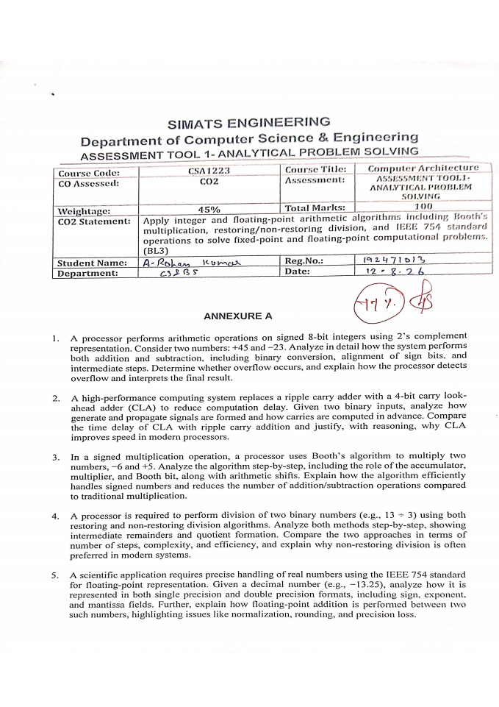
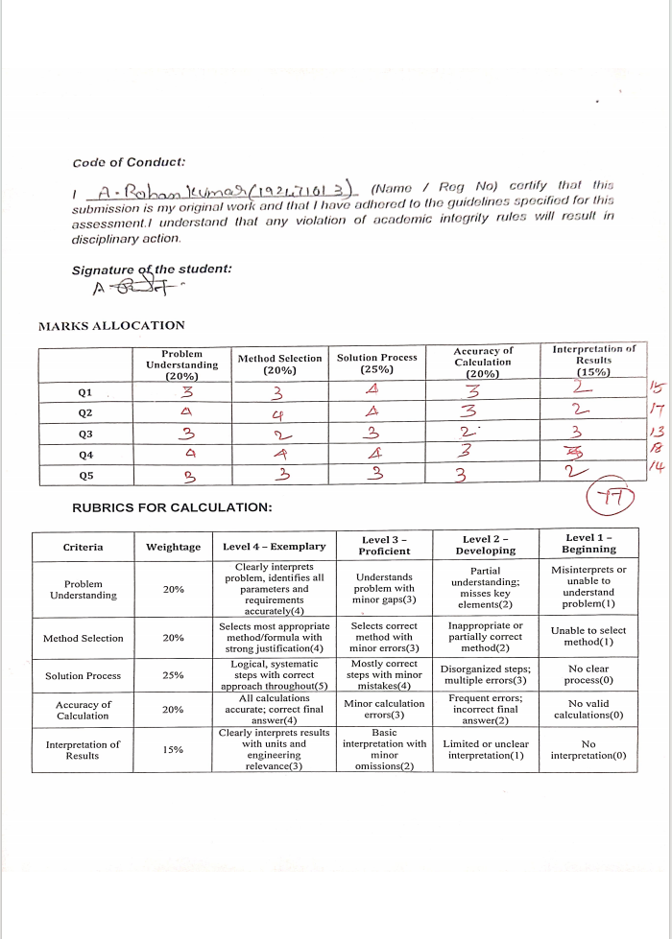
1.A processor performs arithmetic operations on signed 8-bit integers using 2’s
complement representation. Consider two numbers: +45 and −23. Analyze in detail how
the system performs both addition and subtraction, including binary conversion,
alignment of sign bits, and intermediate steps. Determine whether overflow occurs, and
explain how the processor detects overA processor uses 8-bit 2’s complement
representation. The given numbers are +45 and −23.

SIGNED 8-BIT ARITHMETIC

Problem Understanding
A processor performs arithmetic on signed 8-bit integers using 2’s complement representation. The two numbers are +45 and −23. The task is to perform both addition and subtraction, show binary conversion and sign handling, determine overflow, and explain how overflow is detected.

Range of 8-bit 2’s Complement
An 8-bit signed 2’s complement number can represent values from −2^7 to 2^7 − 1.
Range = −128 to +127

Representation of +45
45 can be decomposed as 32 + 8 + 4 + 1. Therefore its 8-bit binary representation is:
45 = 00101101₂

Representation of −23
First represent +23:
23 = 00010111₂
Take the 1’s complement:
00010111 → 11101000
Add 1 to obtain the 2’s complement:
11101000
+ 00000001
-----------
11101001
Therefore:
−23 = 11101001₂

Addition: +45 + (−23)
00101101 (+45)
+ 11101001 (−23)
------------
1 00010110
The carry beyond the eighth bit is discarded. The 8-bit result is:
00010110₂ = 22₁₀
Therefore, 45 + (−23) = +22.

Sign-Bit Interpretation
The most significant bit (MSB) of 00010110 is 0, so the result is positive. This agrees with the decimal calculation 45 − 23 = 22.

Subtraction: +45 − (−23)
In 2’s complement arithmetic, subtraction is performed by adding the 2’s complement of the subtrahend. The subtrahend is −23, whose 2’s complement is +23.
−23 = 11101001
1’s complement of 11101001 = 00010110
Add 1 = 00010111
Thus the processor performs:
45 − (−23) = 45 + 23
00101101 (+45)
+ 00010111 (+23)
------------
01000100
The result is:
01000100₂ = 68₁₀

Overflow Analysis
The signed 8-bit range is −128 to +127. Both +22 and +68 are within this range, so neither operation produces overflow.
Operation | Operands | Result | Overflow?
Addition | +45 + (−23) | +22 | No
Subtraction | +45 − (−23) | +68 | No

How the Processor Detects Overflow
For signed 2’s complement addition, overflow occurs when two operands have the same sign but the result has the opposite sign. An equivalent hardware test is to compare the carry into the sign bit with the carry out of the sign bit. If they differ, signed overflow has occurred.
- Adding two positive numbers and obtaining a negative result indicates overflow.
- Adding two negative numbers and obtaining a positive result indicates overflow.
- Adding numbers with different signs cannot cause signed overflow.
- For +45 + (+23), both operands are positive and the result +68 remains positive, so there is no overflow.
- For +45 + (−23), the signs differ, so there is no signed overflow.

Final Answer
45 + (−23) = +22
45 − (−23) = +68
Overflow = None

2.A high-performance computing system replaces a ripple carry adder with a 4-bit carry
look-ahead adder (CLA) to reduce computation delay. Given two binary inputs, analyze
how generate and propagate signals are formed and how carries are computed in
advance. Compare the time delay of CLA with ripple carry addition and justify, with
reasoning, why CLA improves speed in modern processors.

problem Understanding
A high-performance system replaces a ripple carry adder with a 4-bit Carry Look-Ahead Adder (CLA). The objective is to explain how generate and propagate signals are formed, how carries are calculated in advance, and why CLA is faster.

Generate Signal
For bit i, a carry is generated when both input bits are 1.
Gi = Ai · Bi
For example, if Ai = 1 and Bi = 1, then Gi = 1.

Propagate Signal
A carry is propagated through a bit position when the input combination allows an incoming carry to affect the next stage. A common CLA definition is:
Pi = Ai ⊕ Bi
With this definition, the carry equation is:
Ci+1 = Gi + PiCi

Carry Equations for Four Bits
Let C0 be the input carry. Expanding the equations gives:
C1 = G0 + P0C0
C2 = G1 + P1G0 + P1P0C0
C3 = G2 + P2G1 + P2P1G0 + P2P1P0C0
C4 = G3 + P3G2 + P3P2G1 + P3P2P1G0
+ P3P2P1P0C0

Sum Equations
S0 = P0 ⊕ C0
S1 = P1 ⊕ C1
S2 = P2 ⊕ C2
S3 = P3 ⊕ C3
The important advantage is that C1, C2, C3 and C4 can be formed from the input signals without waiting for a carry to ripple through every full-adder stage.

Ripple Carry Adder
In a Ripple Carry Adder (RCA), each full adder produces a carry that becomes the input to the next full adder. Therefore, the most significant stage may have to wait for all earlier carry signals.
Stage 0 → Stage 1 → Stage 2 → Stage 3
The carry propagates sequentially. As the word size increases, the worst-case carry propagation delay increases approximately with the number of stages.

Carry Look-Ahead Adder
The CLA uses generate and propagate information to calculate carries in parallel. Instead of waiting for C1 before forming C2, the circuit expands C2 directly in terms of G and P signals.
Feature | Ripple Carry Adder | Carry Look-Ahead Adder
Carry formation | Sequential | Parallel/look-ahead
Propagation delay | Higher | Lower
Hardware | Simple | More complex
Wiring/logic | Less | More
High-speed use | Less suitable | Highly suitable

Why CLA Improves Processor Speed
Arithmetic operations are performed frequently in processors. Carry propagation can become a major component of the addition delay. CLA reduces this delay by computing carry signals using Boolean expressions rather than waiting for each previous stage.
- Carry signals are predicted from generate and propagate terms.
- The critical carry path is shortened.
- The approach is particularly useful in ALUs and high-performance arithmetic units.
- The speed benefit is obtained at the cost of additional logic and wiring.

Conclusion
The CLA is faster than a ripple carry adder because it avoids a long sequential carry chain. The question does not provide specific 4-bit A and B values, so a single numerical sum is not specified; the correct analysis is the general generate/propagate and carry formulation above.

3.In a signed multiplication operation, a processor uses Booth’s algorithm to multiply two
numbers, −6 and +5. Analyze the algorithm step-by-step, including the role of the
accumulator, multiplier, and Booth bit, along with arithmetic shifts. Explain how the
algorithm efficiently handles signed numbers and reduces the number of
addition/subtraction operations compared to traditional multiplication.

problem Understanding
Booth’s algorithm is used to multiply signed binary numbers efficiently. The given operation is (−6) × (+5). The method works directly with 2’s complement values and uses an accumulator A, multiplier Q, multiplicand M, and an extra Booth bit Q−1.

Binary Values
For +6:
+6 = 0110
Taking 2’s complement gives −6:
0110 → 1001 → +1 → 1010
M = 1010 = −6
The multiplier is:
Q = 0101 = +5
The additive inverse of M is +6:
−M = 0110

Initial Registers
A = 0000
Q = 0101
M = 1010
Q−1 = 0

Booth Rules
Q0 Q−1 | Operation
00 | No operation
01 | A = A + M
10 | A = A − M
11 | No operation
After each iteration, the combined A, Q and Q−1 registers are subjected to an arithmetic right shift. The sign bit of A is replicated during the shift.

Iteration 1
Initial Q0Q−1 = 10, so perform A = A − M.
0000
− 1010
------
0110
Arithmetic right shift:
0110 0101 0 → 0011 0010 1

Iteration 2
Now Q0Q−1 = 01, so perform A = A + M.
0011
+ 1010
------
1101
Arithmetic right shift:
1101 0010 1 → 1110 1001 0

Iteration 3
Now Q0Q−1 = 10, so perform A = A − M.
1110
− 1010
------
0100
Arithmetic right shift:
0100 1001 0 → 0010 0100 1

Iteration 4
Now Q0Q−1 = 01, so perform A = A + M.
0010
+ 1010
------
1100
Arithmetic right shift:
1100 0100 1 → 1110 0010 0

Final Product
After four iterations:
A = 1110
Q = 0010
Combine A and Q:
11100010
This is a negative 8-bit 2’s complement number. Its magnitude is found by taking its 2’s complement:
11100010 → 00011101 → +1 → 00011110
00011110₂ = 30₁₀. Therefore the final product is −30.

4.A processor is required to perform division of two binary numbers (e.g., 13 ÷ 3) using
both restoring and non-restoring division algorithms. Analyze both methods step-by
step, showing intermediate remainders and quotient formation. Compare the two
approaches in terms of number of steps, complexity, and efficiency, and explain why
non-restoring division is often preferred in modern systems.

Problem Understanding
The processor must divide 13 by 3 using restoring and non-restoring division. The binary values are 1101 and 0011. The expected mathematical result is quotient 4 and remainder 1.
13 = 1101₂
3 = 0011₂
13 ÷ 3 = 4 remainder 1

Restoring Division Principle
Restoring division shifts the partial remainder and subtracts the divisor. If the subtraction gives a negative result, the divisor is added back to restore the previous non-negative partial remainder. The quotient bit is 0 in that case. If the subtraction is non-negative, the quotient bit is 1.

Restoring Division – Conceptual Steps
Stage | Action | Decision
1 | Shift partial remainder and bring down next dividend bit | Subtract divisor
2 | If result is negative | Restore by adding divisor; quotient bit = 0
3 | If result is non-negative | Keep result; quotient bit = 1
4 | Repeat for all dividend bits | Final A is remainder
For 13 ÷ 3, four quotient decisions are made because the dividend contains four bits. The final quotient and remainder are:
Quotient Q = 0100₂ = 4
Remainder A = 0001₂ = 1

Interpretation
The result satisfies the division identity:
Dividend = Divisor × Quotient + Remainder
13 = 3 × 4 + 1
Since the remainder 1 is less than the divisor 3, the result is valid.

Non-Restoring Division Principle
Non-restoring division avoids immediately restoring a negative partial remainder. Instead, the sign of the current partial remainder determines the next operation.
- If the current partial remainder is non-negative, shift and subtract the divisor.
- If the current partial remainder is negative, shift and add the divisor in the next step.
- The quotient bit is selected from the sign of the resulting partial remainder.
- If the final remainder is negative, a final correction by adding the divisor is performed.

Result for 13 ÷ 3
After the required iterations, the non-restoring method produces:
Q = 0100₂ = 4
A = 00001₂ = 1
13 ÷ 3 = 4 remainder 1

Restoring vs Non-Restoring
Criterion | Restoring | Non-Restoring
Negative partial remainder | Immediately restored | Kept temporarily
Extra restoration | May occur repeatedly | Avoided during each iteration
Arithmetic operations | More | Generally fewer
Control logic | Straightforward | More involved
Efficiency | Lower for repeated restoration | Generally better
Result for 13 ÷ 3 | 4 remainder 1 | 4 remainder 1

Conclusion
Both algorithms produce the same mathematical result. Non-restoring division is often preferred for efficient hardware implementations because it avoids unnecessary restoration operations at every negative partial remainder. The trade-off is more complex control logic.

Verification
3 × 4 + 1 = 13
Therefore, the quotient and remainder are correct.

5.A scientific application requires precise handling of real numbers using the IEEE 754
standard for floating-point representation. Given a decimal number (e.g., −13.25),
analyze how it is represented in both single precision and double precision formats,
including sign, exponent, and mantissa fields. Further, explain how floating-point
addition is performed between two such numbers, highlighting issues like normalization,
rounding, and precision loss.

Convert −13.25 to Binary
The integer part is 13 and the fractional part is 0.25.
13 = 1101₂
0.25 = 0.01₂
13.25 = 1101.01₂
Since the number is negative:
−13.25 = −1101.01₂

Normalize
1101.01₂ = 1.10101₂ × 2³
Thus the fields are sign = 1, actual exponent = 3, and fraction = 10101 followed by zeros.

Single Precision (32 bits)
Single precision uses 1 sign bit, 8 exponent bits, and 23 fraction bits. Its exponent bias is 127.
Stored exponent = 3 + 127 = 130
130 = 10000010₂
Sign = 1
Exponent = 10000010
Fraction = 10101000000000000000000
1 | 10000010 | 10101000000000000000000

Double Precision (64 bits)
Double precision uses 1 sign bit, 11 exponent bits, and 52 fraction bits. Its exponent bias is 1023.
Stored exponent = 3 + 1023 = 1026
1026 = 10000000010₂
Sign = 1
Exponent = 10000000010
Fraction = 1010100000000000000000000000000000000000000000000000
1 | 10000000010 | 1010100000000000000000000000000000000000000000000000

Floating-Point Addition
Floating-point addition requires alignment of exponents before the significands can be added. The general sequence is: compare exponents, shift the smaller significand, add or subtract significands according to their signs, normalize the result, round if required, and store the final sign, exponent and fraction.
- Exponent alignment: shift the significand of the number with the smaller exponent.
- Significand operation: add magnitudes for equal signs or subtract magnitudes for different signs.
- Normalization: shift the result so it has one leading non-zero bit.
- Exponent adjustment: increase or decrease the exponent to match normalization.
- Rounding: discard extra bits according to the selected IEEE 754 rounding mode.
- Precision loss: rounding can cause a small difference between the exact mathematical result and stored result.

Overall Conclusion
The five problems demonstrate how computer hardware performs integer and floating-point arithmetic. 2’s complement makes signed addition and subtraction possible with the same binary adder. CLA reduces carry propagation delay. Booth’s algorithm efficiently handles signed multiplication. Restoring and non-restoring division produce quotient and remainder through repeated shift and arithmetic operations. IEEE 754 provides a standardized representation for real numbers and defines how normalization and rounding are handled.

Final Results
Question | Final Result
Q1 | 45 + (−23) = 22; 45 − (−23) = 68; no overflow
Q2 | CLA uses Gi = AiBi and Pi = Ai⊕Bi to calculate carries ahead of time
Q3 | (−6) × (+5) = −30
Q4 | 13 ÷ 3 = 4 remainder 1
Q5 | −13.25 = −1.10101₂ × 2³; IEEE 754 fields shown above

